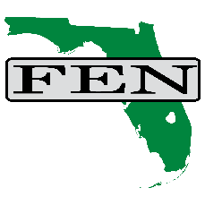

General Membership Meeting
Friday, September 26, 2025, at the DoubleTree Hilton, St. Augustine.

Agenda

7:30 AM - FEN-sponsored breakfast.
8:30 AM - Welcome, Dr. Adrienne McElroy, President, FEN.

Navigating FMLA and ADA: Reducing Risk, Supporting Employees. A practical session unpacking the intersection of FMLA leave entitlements and ADA accommodations, with strategies to minimize risk and support employees effectively. Presenter Leonard Dietzen, Esq., Partner, Rumberger | Kirk.

Making Sense of FEFP Data. Understanding the 2nd and 3rd FEFP calculations including tips for explaining data in ways that resonate with labor managers. Presenters: Scott Ward, CFO, Lake County School District and Bonnie Penner, CFO, Columbia County School District.

Beyond the Headcount – Understanding FTE Budgeting. Why more students don’t always translate into more dollars, breaking down the realities of FTE funding, and an interactive discussion for communicating these nuances effectively. Presenters: Scott Ward, CFO Lake County School District and Bonnie Penner, CFO, Columbia County School District.

Negotiation Insights Exchange. An open forum for participants to share updates on negotiations - what’s working, what’s difficult, and success stories. Facilitated by FEN Officers.

12:30 PM - Adjourn.


Presenter Materials: WIFI Password: premiumguest

Future Meetings
Friday, Oct. 24, 2025 – General Membership Meeting, Hotel Alba, Tampa
Friday, Jan. 30, 2026 – General Membership Meeting, Rosen Center, Orlando
Friday, Feb. 27, 2026 – General Membership Meeting, Hotel Duval, Tallahassee

If you have recommendations for our meetings or specific program needs, please email the FEN office at watson@flfen.org. We look forward to hearing from you.

